Can you provide a detailed step by step procedure of how to test a mediation model with multiple independent variables, two chain mediators and one outcome variable, please?
ChatGPT said:
Testing a mediation model with multiple independent variables (IVs), two chain mediators, and one outcome variable (DV) involves several steps. This type of analysis typically examines the direct and indirect effects of the independent variables on the dependent variable, mediated through the chain of mediators. The following is a step-by-step guide to perform this analysis.
Step-by-Step Procedure:

1. Understand the Structure of Your Model
- Independent Variables (IVs): You have more than one IV. These are the predictors that are believed to influence the outcome variable (DV) through the chain of mediators.
- Mediators: Two mediators that are supposed to explain how or why the IVs affect the DV.
- Outcome Variable (DV): The dependent variable you're interested in explaining.
In this case, the model looks like this:
- IVs (X1, X2) → Mediator 1 (M1) → Mediator 2 (M2) → DV (Y)
You are looking to test both direct effects (from IVs to DV) and indirect effects (from IVs to DV through M1 and M2).

2. Set Up the Hypotheses
You can structure hypotheses around the relationships:
- Direct Effects:
  - X1 → Y (Direct effect of IV1 on the DV)
  - X2 → Y (Direct effect of IV2 on the DV)
- Indirect Effects:
  - X1 → M1 → M2 → Y (Indirect effect of IV1 through the chain of mediators)
  - X2 → M1 → M2 → Y (Indirect effect of IV2 through the chain of mediators)

3. Collect Data
Ensure that you have data for all your variables (IVs, mediators, and DV). Make sure to check the data for any issues like missing values, outliers, or normality, as these can affect the analysis.

4. Choose an Analysis Method
- Path Analysis (a specific case of Structural Equation Modeling, SEM) is typically used for mediation models.
- Multiple Mediation Models: Since you have multiple IVs, two mediators, and one DV, you will need to set up a model with multiple mediators.
- Bootstrapping: This is a non-parametric method often used in mediation analysis to estimate indirect effects. It is recommended because it gives more accurate estimates for indirect effects (which can be non-normal).
The most common tool for conducting this analysis is SPSS (with the PROCESS macro), R, or Mplus. Below, I will describe how to do this analysis in SPSS with PROCESS and R.

5. Conduct the Analysis
A. SPSS with the PROCESS Macro:
- Install the PROCESS Macro:
  - Download and install the PROCESS macro from Andrew Hayes’ website (www.processmacro.org).
- Run the Model in SPSS:
  - Open your dataset in SPSS.
  - Go to Analyze > Regression > PROCESS.
  - In the PROCESS dialog box:
    - Select your dependent variable (Y).
    - Select your independent variables (X1, X2).
    - Select your mediators (M1, M2).
    - Choose the model number: For a model with two mediators, select Model 6 or a custom model specifying the chain.
  - Specify bootstrapping (set the number of bootstrap samples to 5,000 or more).
- Interpret the Results:
  - The output will provide coefficients for each path (X1 → M1, M1 → M2, M2 → Y, and so on).
  - Look for:
    - Direct effects: Direct effects of X1 and X2 on Y.
    - Indirect effects: Indirect effects (via the chain of mediators) using bootstrapped confidence intervals.
    - Total effect: The combined effect (direct + indirect).
B. R (using the lavaan or mediation package):
- Install Required Packages:
R
CopyEdit
install.packages("lavaan")
install.packages("mediation")
- Fit the Mediation Model:
  - Define your mediation model in R using lavaan (for SEM).
R
CopyEdit
library(lavaan)

model <- '
# Direct effects
M1 ~ c1*X1 + c2*X2
M2 ~ b1*M1
Y ~ b2*M2 + d1*X1 + d2*X2

# Indirect effects
indirect_X1_Y := c1*b1*b2
indirect_X2_Y := c2*b1*b2
'

fit <- sem(model, data = your_data)

summary(fit, standardized = TRUE, fit.measures = TRUE)
- Interpret the Results:
  - Check the estimates for each path.
  - Look at standardized coefficients to understand the relative importance of each path.
  - Evaluate indirect effects and their confidence intervals.
- Bootstrapping (for indirect effects):
Use the mediation package for bootstrapped estimates:
R
CopyEdit
library(mediation)

model.mediation <- lm(M1 ~ X1 + X2, data = your_data)
model.outcome <- lm(Y ~ M2 + M1 + X1 + X2, data = your_data)

mediation.result <- mediate(model.mediation, model.outcome, treat = "X1", mediator = "M1", boot = TRUE, sims = 5000)
summary(mediation.result)

6. Check Model Fit and Assumptions
- Goodness-of-Fit: Check the model fit indices (like RMSEA, CFI, TLI) if you're using SEM or path analysis (in lavaan).
- Normality of Indirect Effects: For bootstrapping, check the bias-corrected confidence intervals of the indirect effects to ensure they do not include zero, indicating a significant mediation effect.

7. Interpretation of Results
- Direct Effects:
  - Are the direct paths from the IVs to the DV significant?
  - If so, this suggests a direct relationship between the IVs and the DV, aside from the mediation effects.
- Indirect Effects:
  - The indirect effect represents how the IVs affect the DV through the mediators (M1 and M2).
  - If the 95% confidence intervals for the indirect effect do not include zero, the mediation effect is considered significant.
- Total Effect:
  - This is the combined effect of direct and indirect effects. Check if this is significant.

8. Report the Results
- Direct Effects: Report the direct paths between the IVs and the DV.
- Indirect Effects: Report the indirect paths, confidence intervals (bootstrapped), and the total indirect effect.
- Model Fit: Report the goodness-of-fit indices (if applicable).

Summary:
In summary, testing a mediation model with multiple independent variables, chain mediators, and one dependent variable involves specifying your model, conducting the analysis using appropriate tools like SPSS with PROCESS, or SEM in R, checking the significance of both direct and indirect effects, and interpreting the results accordingly. Using bootstrapping methods is essential for assessing the indirect effects with greater accuracy.
Would you like more specific guidance on using a particular tool for this analysis?
You said:
Yes, in python please
ChatGPT said:
Sure! Here’s how you can test a mediation model in Python with multiple independent variables, two chain mediators, and one dependent variable. We'll use statsmodels and pingouin libraries for this task, and you can also use mediation for more advanced mediation analysis if needed.
Below is a step-by-step guide for testing this mediation model in Python.
Step-by-Step Procedure in Python:

Step 1: Install Required Libraries
If you don't have them installed yet, you'll need to install the following Python libraries:
bash
CopyEdit
pip install statsmodels pingouin
- statsmodels is used for linear regression analysis.
- pingouin is a statistics library that has an easy-to-use function for mediation analysis.

Step 2: Import Libraries
python
CopyEdit
import numpy as np
import pandas as pd
import statsmodels.api as sm
import pingouin as pg

Step 3: Define Your Model
In this example, you have:
- Two independent variables: X1 and X2
- Two mediators: M1 and M2
- One dependent variable: Y
The model you want to test is:
- X1 → M1 → M2 → Y
- X2 → M1 → M2 → Y
We want to estimate both the direct and indirect effects.

Step 4: Prepare Your Data
Make sure you have your data in a pandas DataFrame format. Your DataFrame should have columns for X1, X2, M1, M2, and Y.
python
CopyEdit
# Example data
data = pd.DataFrame({
'X1': np.random.randn(100), # Independent Variable 1
'X2': np.random.randn(100), # Independent Variable 2
'M1': np.random.randn(100), # Mediator 1
'M2': np.random.randn(100), # Mediator 2
'Y': np.random.randn(100) # Dependent Variable
})

Step 5: Set Up the Regression Models for Each Path
- X1 → M1: Regression of M1 on X1
- X2 → M1: Regression of M1 on X2
- M1 → M2: Regression of M2 on M1
- M2 → Y: Regression of Y on M2
- X1 → Y: Regression of Y on X1 (direct effect)
- X2 → Y: Regression of Y on X2 (direct effect)

Step 6: Fit the Models
1. X1 → M1
python
CopyEdit
X1_M1 = sm.OLS(data['M1'], sm.add_constant(data['X1'])).fit()
print(X1_M1.summary())
2. X2 → M1
python
CopyEdit
X2_M1 = sm.OLS(data['M1'], sm.add_constant(data['X2'])).fit()
print(X2_M1.summary())
3. M1 → M2
python
CopyEdit
M1_M2 = sm.OLS(data['M2'], sm.add_constant(data['M1'])).fit()
print(M1_M2.summary())
4. M2 → Y
python
CopyEdit
M2_Y = sm.OLS(data['Y'], sm.add_constant(data['M2'])).fit()
print(M2_Y.summary())
5. X1 → Y (Direct Effect)
python
CopyEdit
X1_Y = sm.OLS(data['Y'], sm.add_constant(data['X1'])).fit()
print(X1_Y.summary())
6. X2 → Y (Direct Effect)
python
CopyEdit
X2_Y = sm.OLS(data['Y'], sm.add_constant(data['X2'])).fit()
print(X2_Y.summary())

Step 7: Calculate the Indirect Effects (Mediation)
Once the regression models are fit, you can calculate the indirect effects (i.e., the mediation paths):
- Indirect effect of X1 → M1 → M2 → Y:
  - Indirect Effect = (X1 → M1) * (M1 → M2) * (M2 → Y)
- Indirect effect of X2 → M1 → M2 → Y:
  - Indirect Effect = (X2 → M1) * (M1 → M2) * (M2 → Y)
Now, compute the indirect effects:
python
CopyEdit
# Indirect effect of X1 through M1 and M2
indirect_X1 = X1_M1.params[1] * M1_M2.params[1] * M2_Y.params[1]

# Indirect effect of X2 through M1 and M2
indirect_X2 = X2_M1.params[1] * M1_M2.params[1] * M2_Y.params[1]

print(f"Indirect effect of X1: {indirect_X1}")
print(f"Indirect effect of X2: {indirect_X2}")

Step 8: Use pingouin to Run a Full Mediation Analysis
You can use pingouin's mediation function, which simplifies testing the mediation model, including bootstrapping the indirect effects:
python
CopyEdit
# Mediation analysis with pingouin
mediation_results = pg.mediation(data=data, x=['X1', 'X2'], m=['M1', 'M2'], y='Y', bootstrap=5000)

# View the mediation results
print(mediation_results)
This will return the direct and indirect effects with bootstrapped confidence intervals, which will help you assess the significance of the mediation effects.

Step 9: Interpretation of Results
- Direct Effects: These are the coefficients from the regressions X1 → Y and X2 → Y. If these coefficients are significant, the independent variables have a direct effect on the outcome variable.
- Indirect Effects: The indirect effects represent the mediation pathways (e.g., X1 → M1 → M2 → Y). A significant indirect effect (non-zero confidence intervals) indicates that the mediation is statistically significant.
- Total Effect: This is the combination of the direct and indirect effects. You can sum the coefficients to get the total effect, which represents the overall relationship between the IVs and the DV.

Step 10: Reporting the Results
You would report the following:
- The direct effects of X1 and X2 on Y.
- The indirect effects via M1 and M2.
- Confidence intervals (bootstrapped) for the indirect effects.
- Whether the indirect effects are significant (i.e., if the bootstrapped confidence intervals do not contain zero).

Conclusion
This is how you can test a mediation model with multiple independent variables, chain mediators, and one dependent variable in Python. Using statsmodels allows you to perform the regressions, and pingouin offers an easy way to calculate and bootstrap the mediation effects.
Would you like to go deeper into any specific part of this process or see a more detailed example?
You said:
Yes, a more detailed example would be great
ChatGPT said:
Perfect! Here's a complete, detailed example of testing a mediation model in Python with two independent variables (X1 and X2), two chained mediators (M1 and M2), and one outcome variable (Y).
We'll simulate data and walk through the full process using:
- pandas and numpy for data handling
- statsmodels for the regression steps
- pingouin for mediation analysis

🧪 Goal of the Mediation Analysis
We want to examine whether the effect of X1 and X2 on Y is mediated through M1 and M2, in a sequential (chain) mediation model.
Model path:
nginx
CopyEdit
X1 → M1 → M2 → Y
X2 → M1 → M2 → Y

✅ Step-by-Step in Python
📦 Step 1: Install & Import Required Libraries
bash
CopyEdit
pip install pandas numpy statsmodels pingouin
Now import:
python
CopyEdit
import numpy as np
import pandas as pd
import statsmodels.api as sm
import pingouin as pg

🧰 Step 2: Simulate Example Data
python
CopyEdit
np.random.seed(42) # Reproducibility
n = 300

# Independent variables
X1 = np.random.normal(0, 1, n)
X2 = np.random.normal(0, 1, n)

# First mediator depends on X1 and X2
M1 = 0.6 * X1 + 0.3 * X2 + np.random.normal(0, 1, n)

# Second mediator depends on M1
M2 = 0.7 * M1 + np.random.normal(0, 1, n)

# Outcome depends on M2, X1 and X2 (direct + indirect paths)
Y = 0.5 * M2 + 0.2 * X1 + 0.1 * X2 + np.random.normal(0, 1, n)

# Combine into DataFrame
data = pd.DataFrame({'X1': X1, 'X2': X2, 'M1': M1, 'M2': M2, 'Y': Y})

📉 Step 3: Run Regressions for Each Path Using statsmodels
python
CopyEdit
# X1 and X2 → M1
model_M1 = sm.OLS(data['M1'], sm.add_constant(data[['X1', 'X2']])).fit()
print("M1 regression:\n", model_M1.summary())

# M1 → M2
model_M2 = sm.OLS(data['M2'], sm.add_constant(data[['M1']])).fit()
print("\nM2 regression:\n", model_M2.summary())

# M2, X1, X2 → Y (final outcome regression)
model_Y = sm.OLS(data['Y'], sm.add_constant(data[['M2', 'X1', 'X2']])).fit()
print("\nY regression:\n", model_Y.summary())

🔁 Step 4: Calculate Indirect Effects Manually
We will compute the chained indirect effect:
- X1 → M1 → M2 → Y
- X2 → M1 → M2 → Y
python
CopyEdit
# Extract coefficients
a1 = model_M1.params['X1'] # X1 → M1
a2 = model_M1.params['X2'] # X2 → M1
b1 = model_M2.params['M1'] # M1 → M2
b2 = model_Y.params['M2'] # M2 → Y

# Indirect effects
indirect_X1 = a1 * b1 * b2
indirect_X2 = a2 * b1 * b2

print(f"Indirect effect of X1 via M1 → M2 → Y: {indirect_X1:.4f}")
print(f"Indirect effect of X2 via M1 → M2 → Y: {indirect_X2:.4f}")

🧪 Step 5: Use pingouin for Mediation Analysis with Bootstrapping
Note: pingouin.mediation() handles one IV and one mediator at a time, so we’ll analyze each path step-by-step:
First: X1 → M1 → M2 (single-step mediation)
python
CopyEdit
pg.mediation(data=data, x='X1', m='M1', y='M2', alpha=0.05, seed=42, bootstrap=5000)
Then: M1 → M2 → Y (to examine the second link in the chain)
python
CopyEdit
pg.mediation(data=data, x='M1', m='M2', y='Y', alpha=0.05, seed=42, bootstrap=5000)
You can manually multiply these two indirect paths to estimate the full indirect effect.
Unfortunately, pingouin does not support full chain mediation in one call (like PROCESS model 6 in SPSS). For that, you'd need SEM in R (lavaan) or Python SEM libraries like semopy or lavaanpy.

📌 Optional: Use SEM (structural equation modeling) in Python
If you're familiar with path models and want to test the full chain in one model, we can use semopy. Let me know and I’ll provide an SEM example.

✅ Summary Output
After this, you’ll have:
- Coefficients for direct paths from X1, X2 → Y
- Indirect effects of X1, X2 through M1 → M2 → Y
- Bootstrapped confidence intervals for each mediation step
- You can conclude whether sequential mediation exists

Would you like a visual path diagram or to explore the SEM version of this analysis?
You said:
A visual path diagram would be great
ChatGPT said:
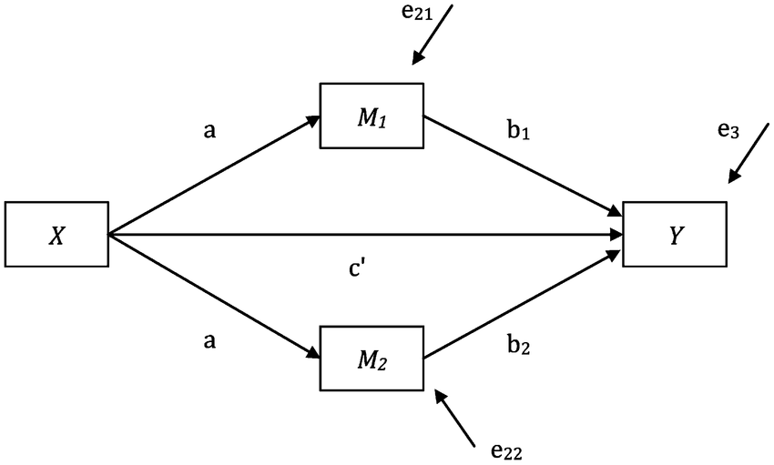
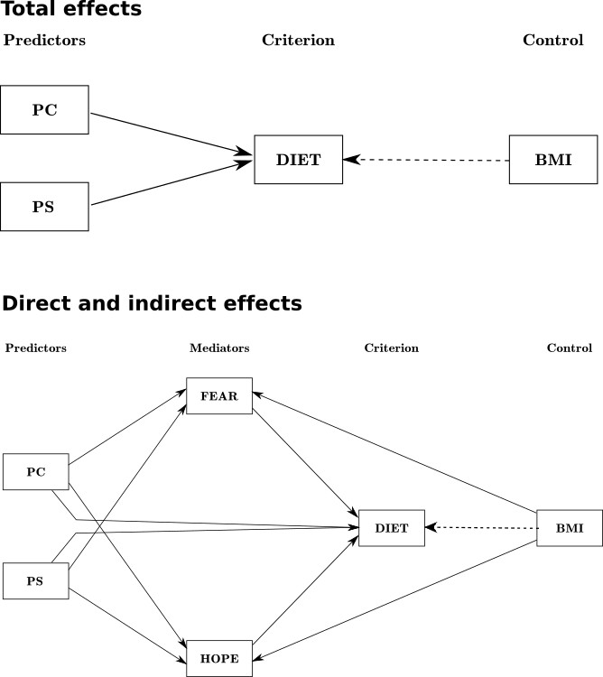
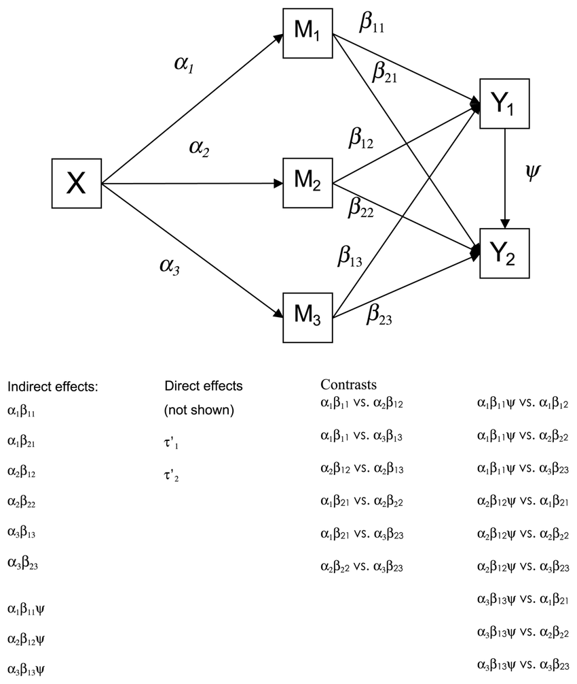
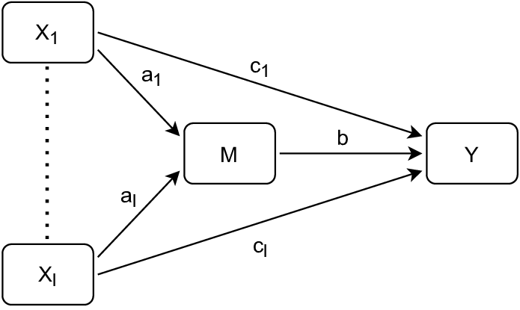
Absolutely! Visualizing your mediation model with a path diagram is an excellent way to communicate the relationships between variables. Here's how you can create a clear and informative path diagram for your model using Python.

🧩 Visualizing the Mediation Model with semopy
To create a path diagram in Python, we can use the semopy library, which allows for structural equation modeling and visualization.
📦 Step 1: Install semopy
If you haven't installed semopy yet, you can do so using pip:
bash
CopyEdit
pip install semopy
🛠️ Step 2: Define the Model and Data
python
CopyEdit
import numpy as np
import pandas as pd
from semopy import Model

# Simulate data
np.random.seed(42)
n = 300
X1 = np.random.normal(0, 1, n)
X2 = np.random.normal(0, 1, n)
M1 = 0.6 * X1 + 0.3 * X2 + np.random.normal(0, 1, n)
M2 = 0.7 * M1 + np.random.normal(0, 1, n)
Y = 0.5 * M2 + 0.2 * X1 + 0.1 * X2 + np.random.normal(0, 1, n)

data = pd.DataFrame({'X1': X1, 'X2': X2, 'M1': M1, 'M2': M2, 'Y': Y})

# Define the model
desc = """
# Measurement model
M1 =~ X1 + X2
M2 =~ M1
Y =~ M2 + X1 + X2

# Structural model
M1 ~ X1 + X2
M2 ~ M1
Y ~ M2 + X1 + X2
"""

# Create and fit the model
model = Model(desc)
model.fit(data)
📊 Step 3: Visualize the Path Diagram
python
CopyEdit
import matplotlib.pyplot as plt
from semopy import plot

# Plot the model
plot(model, layout='spring')
plt.show()
This code will generate a path diagram where:
- X1 and X2 are the independent variables.
- M1 and M2 are the mediators.
- Y is the dependent variable.
- Arrows represent the hypothesized relationships between variables.

🖼️ Example Path Diagram
Here's an example of what the path diagram might look like:

Source: ResearchGate

✅ Summary
- Model Structure: Your model includes two independent variables (X1, X2), two mediators (M1, M2), and one dependent variable (Y).
- Visualization: Using semopy, you can define and visualize the relationships between these variables in a clear path diagram.
- Interpretation: The diagram helps in understanding the direct and indirect effects within your mediation model.
If you need further customization or have specific questions about interpreting the path diagram, feel free to ask!

